
FOR IMMEDIATE RELEASE: Tuesday 16th June 2026

Oxford Climate Choir Calls for Rewilding of Church Land in Performance Outside Christ Church Cathedral
Members of the Climate Choir Movement to perform outside Christ Church Cathedral, urging General Synod members to support historic motion to restore nature on Church-owned land
Oxford: Saturday 20th June, 12:30pm: The Oxford Climate Choir will perform outside Christ Church Cathedral, calling on members of the Church of England’s General Synod to support a landmark motion to protect and restore nature on Church-owned land.
The performance comes ahead of the Church of England’s General Synod meeting in York this July, where members will debate and vote on a Private Members’ Motion submitted by the Revd Canon of Christ Church Cathedral, Oxford, Valerie Plumb. The motion calls on the Church to support the restoration of nature on 30% of Church land by 2030, in line with the international “30x30” target and “the scale and urgency of the climate and biodiversity crises.” [1]
The motion has already secured the support of more than 100 clergy and Synod members, meaning it must now be formally debated and voted on at Synod.
The Oxford action is part of a wider national effort organised by the Climate Choir Movement and rewilding campaign group Wild Card to encourage Synod members to support what campaigners describe as a hopeful, practical, and unifying call to action.
The Church of England is one of the UK’s largest landowners, with an estate of at least 100,000 acres managed by the Church Commissioners. Environmental campaigners argue that the Church therefore has a unique opportunity to demonstrate meaningful leadership on climate and biodiversity through the stewardship of its land.
Wild Card - the grassroots rewilding movement supported by broadcaster and naturalist Chris Packham - has been campaigning for the Church Commissioners to dedicate 30% of Church land to nature restoration and rewilding. Last year, members of the Climate Choir Movement occupied St Paul’s Cathedral in support of the campaign.
Campaigners point out that the Church Commissioners previously agreed to the Church of England’s divestment from fossil fuels and say the Church now has another opportunity to demonstrate moral and environmental leadership.
In the Getting Back to the Garden report commissioned by Wild Card, campaigners argue that protecting 30% of Church land for nature restoration could be cost-neutral and potentially profitable in some scenarios, demonstrating that ambitious environmental action need not come at the expense of financial sustainability.
“Revd Canon Valerie Plumb has shown courageous and hopeful leadership in bringing this motion forward,” said Joanna Gill, Musical Director of the Oxford Climate Choir. “At a time when people are searching for signs of moral leadership on the climate and nature crises, this proposal offers the Church a chance to act with vision, compassion and responsibility. We hope Synod members will come together behind this historic opportunity to restore nature and leave a lasting legacy for future generations.”
Wild Card Co-founder Hazel Draper added: “The Church of England is one of the country’s major landowners and has the potential to become a national leader in nature recovery. This motion is an opportunity to show real ambition at a critical moment and demonstrate that the Church is serious about responding to the climate and biodiversity crises.”
The action continues a growing series of creative public interventions organised by the Climate Choir Movement and Wild Card to raise awareness about climate breakdown, biodiversity loss, and the responsibility of major institutions to act.
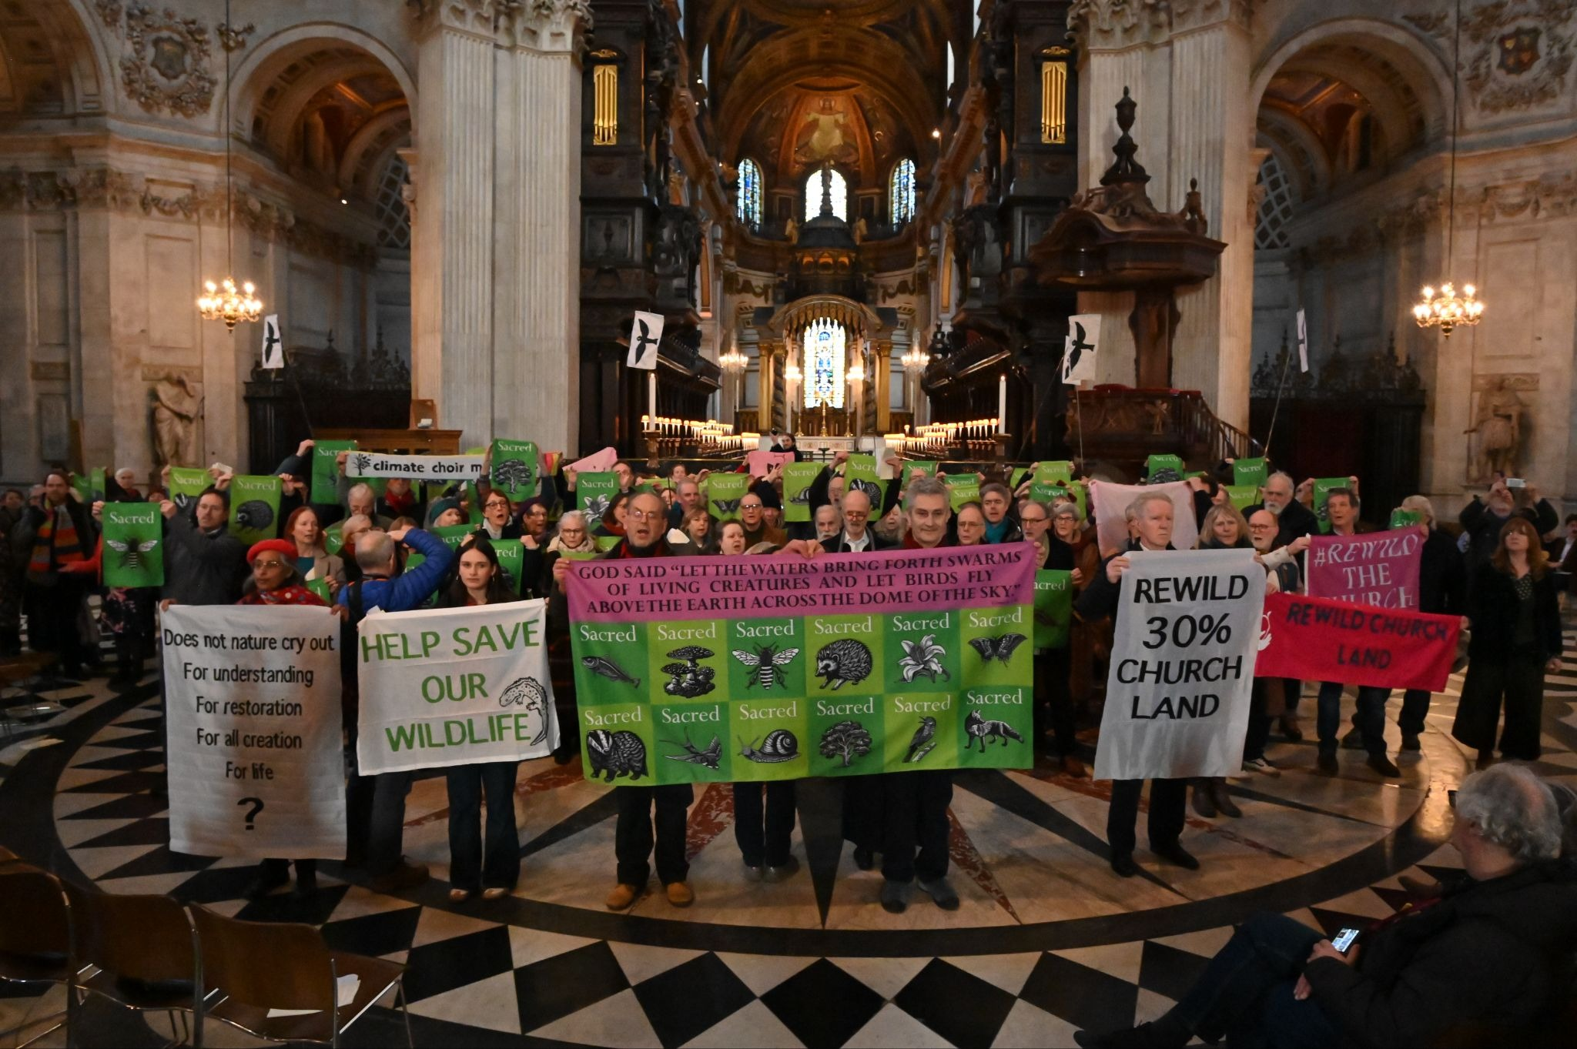

The Climate Choir Movement and Wild Card in St Paul’s Cathedral London March 2025

- ENDS -

NOTES TO EDITORS

[1] https://www.churchofengland.org/about/governance/general-synod/special-agendas/private-members-motions#na
- Members of the Oxford Climate Choir will sing outside Christ Church Cathedral, from 12:30–1:30pm on Saturday 20th June.
- The action calls on Church General Synod members to support a motion on protecting and restoring nature on Church Commissioners’ land.
- The Private Members’ Motion submitted by Revd Canon Valerie Plumb has received more than 100 signatures and will therefore be debated and voted on at the General Synod in York this July.
- The Church of England is one of the UK’s largest landowners, with an estate of at least 100,000 acres.
- Wild Card is a grassroots nature campaign advocating for large-scale ecosystem restoration and wildlife protection across Britain.
- The Climate Choir Movement uses music and public performance to communicate climate and environmental issues through peaceful creative action.
CONTACT INFORMATION

CLIMATE CHOIR MOVEMENT: Kimberly Price 07546 333837 Kai Honey 07579 019056 media@climatechoirmovement.org @climatechoirs
WILD CARD: Heather Carswell: 07815 741183 press@wildcard.land @wildcardcampaign

SOCIAL MEDIA #RewildTheChurch #ChurchOfEngland #ClimateChoirs #ChristChurchCathedral

VISUALS
Images and videos will be available here from 2pm Saturday 20th June.

ABOUT THE CLIMATE CHOIR MOVEMENT
Founded in 2022, the growing Climate Choir Movement is comprised of 900 singers in 17 different choirs across the UK - Ballycastle, Bath, Bristol, Cambridge, Derbyshire, Exeter, Forest of Dean, Guildford, Hay-on-Wye, London, Oxford, Plymouth, Portsmouth, Sheffield, Southampton, Wyre Forest - and in Kentucky, Kenya and Zimbabwe. It uses musical performance to highlight the climate crisis. www.climatechoirmovement.org

ABOUT WILD CARD
Further details about the Rewild the Church campaign can be found here.
Wild Card is a citizens' movement campaigning for the UK’s biggest landowners to urgently rewild their lands in response to the climate and nature emergency. With over 250,000 people supporting their campaigns to date they have already claimed successes in persuading the royal estates and other landowners to begin ambitious nature restoration schemes. www.wildcard.land

